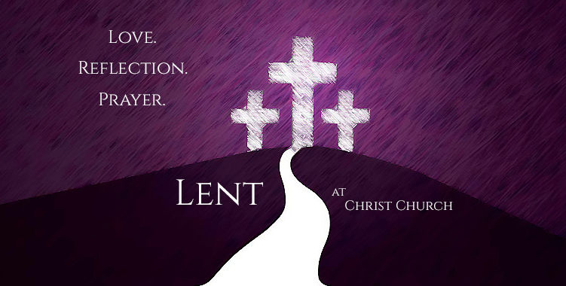

**At**

**Christ the Redeemer**

**Roman Catholic Church**

**Grand Terrace, CA**

**1st Stations of the Cross – March 7 | 6:30 pm| Church**

followed by Soup Supper in the Parish Hall

**2nd Stations of the Cross – March 14| 6:30 pm| Church**

followed by Fry Dinner Fundraiser in the Parish Hall

Tickets will be sold the weekends of March 1-2 and March 8-9 after Mass

**3rd Stations of the Cross – March 21| 6:30 pm| Church**

followed by Soup Supper in the Parish Hall

**4th Stations of the Cross – March 28| 6:30 pm| Church**

followed by Soup Supper in the Parish Hall

**5th Stations of the Cross – April 4| 6:30 pm| Church**

followed by Soup Supper in the Parish Hall

**6th Stations of the Cross – April 11| 6:30 pm | Church**

followed by Fry Dinner Fundraiser in the Parish Hall

Tickets will be sold the weekends of March 1-2 and March 8-9 after Mass